E-Store System

SR | USER Requirements | GPT Results | VeriGen Results
 | The system displays all the products that can be configured. | 1. The system shall display all products that can be configured. | 1. The system shall be able to display all the products that configured.
 | The system allows user to select the product to configure. | 2. The system shall provide the ability to select a product to configure. | 2. The system shall be able to allow to select the product to configure.
 | The system displays all the available components of the product to configure. | 3. The system shall display all available components of the selected product for configuration. | 3. The system shall be able to display all the available components of the product to configure.
 | The system enables user to add one or more component to the configuration. | 4. The system shall provide the ability to add one or more components to the current configuration. | 4. The system shall be able to enable user to add one or more component to the configuration.
 | The system notifies the user about any conflict in the current configuration. | 5. The system shall notify about any conflict in the current configuration. | 5. The system shall be able to notify the user about any conflict in the current configuration.
 | The system allows user to update the configuration to resolve conflict in the current configuration. | 6. If a conflict exists in the current configuration, then the system shall provide the ability to update the configuration to resolve the conflict. | 6. The system shall be able to allow to update the configuration to resolve conflict in the current configuration.
 | The system allows user to confirm the completion of current configuration. | 7. The system shall provide the ability to confirm the completion of the current configuration. | 7. The system shall be able to allow to confirm the completion of current configuration.
 | The system displays detailed information of the selected products. | 8. The system shall display detailed information for the selected products. | 8. The system shall be able to display detailed information of the selected products.
 | The system provides browsing options to see product details. | 9. The system shall provide browsing options to view product details. | 9. The system shall be able to provide browsing options to see product details.
 | The system displays detailed product categorization to the user. | 10. The system shall display detailed product categorization. | 10. The system shall be able to display detailed product categorization to the user.
 | The system enables user to enter the search text on the screen. | 11. The system shall provide the ability to enter search text on the screen. | 11. The system shall be able to enable user to enter the search text on the screen.
 | The system enables user to select multiple options on the screen to search. | 12. The system shall provide the ability to select multiple search options on the screen. | 12. The system shall be able to enable user to select multiple options on the screen to search.
 | The system displays all the matching products based on the search. | 13. The system shall display all matching products based on the search criteria. | 13. The system shall be able to display all the matching products based on the search.
 | The system displays only 10 matching results on the current screen. | 14. The system shall display only 10 matching results per search results screen. | 14. The system shall be able to display only 10 matching results on the current screen.
 | The system enables user to navigate between the search results. | 15. The system shall provide the ability to navigate between search results pages. | 15. The system shall be able to enable user to navigate between the search results.
 | The system notifies the user when no matching product is found on the search. | 16. If no matching product is found during a search, then the system shall notify accordingly. | 16. The system shall be able to notify the user when no matching product found on the search.
 | The system allows user to create profile and set his credential. | - The system shall provide the ability to create a profile.  18. The system shall provide the ability to set credentials during profile creation. | 17. The system shall be able to allow to create profile.  18. The system shall be able to set credential.
 | The system authenticates user credentials to view the profile. | 19. The system shall authenticate credentials to allow profile viewing. | 19. The system shall be able to authenticate user credentials to view the profile for cross check.
 | The system allows user to update the profile information. | 21. The system shall provide the ability to update profile information. | 20. The system shall be able to allow to update the profile information.
 | The system displays both the active and completed order history in the customer profile. | 22. The system shall display both active and completed order history within the customer profile. | 21. The system shall be able to display both the active and completed order history clearly and accurately in the customer profile.
 | The system allows user to select the order from the order history. | 23. The system shall provide the ability to select an order from the order history. | 22. The system shall be able to allow to select the order from the order history.
 | The system displays the detailed information about the selected order. | 24. The system shall display detailed information about the selected order. | 23. The system shall be able to display the detailed information about the selected order including shipping method, payment method, tax information, invoice details, and current tracking status.  .
 | The system displays the most frequently searched items by the user in the profile. | 25. The system shall display the most frequently searched items by the user in the profile. | 24. The system shall be able to display the most frequently searched items by the user in the profile.
 | The system allows user to register for newsletters and surveys in the profile. | - The system shall provide the ability to register for newsletters within the profile.  27. The system shall provide the ability to register for surveys within the profile. | 25. The system shall be able to allow to register for newsletters and surveys in the profile by entering their email information and selecting available newsletter.
 | The system provides online help, FAQ’s customer support, and sitemap options for customer support. | 28 The system shall provide online help options for customer support.  29 The system shall provide FAQ options for customer support.  30 The system shall provide sitemap options for customer support. | 26. The system shall be able to provide online help , faqs customer support , and sitemap options for customer support.
 | The system allows user to select the support type he wants. | 31 The system shall provide the ability to select the type of support desired. | 27. The system shall be able to allow to select the support type he wants from the support screen by choosing one of the available options.
 | The system allows user to enter the customer and product information for the support. | 32 The system shall provide the ability to enter customer information for support requests.  33 The system shall provide the ability to enter product information for support requests. | 28. The system shall be able to allow to enter the customer and product information for the support.
 | The system displays the customer support contact numbers on the screen. | 34 The system shall display customer support contact numbers on the screen. | 29. The system shall be able to display the customer support contact numbers on the screen along with different support types, including online help and FAQs.
 | The system allows user to enter the contact number for support personnel to call. | 35 The system shall provide the ability to enter a contact number for support personnel to call. | 30. The system shall be able to allow to enter the contact number for support personnel to call after selecting the support type and providing customer and product information.
 | The system displays the online help upon request. | 36 The system shall display online help upon request. | 31. The system shall be able to display the online help upon request.
 | The system displays the FAQ’s upon request. | 37 The system shall display FAQs upon request. | 32. The system shall be able to display the faqs upon request.
 | The system maintains customer email information as a required part of customer profile. | 38 The system shall require customer email information as part of the customer profile. | 33. The system shall be able to maintain customer email information as a required part of customer profile.
 | The system sends an order confirmation to the user through email. | 39 The system shall send an order confirmation via email upon order confirmation. | 34. The system shall be able to send an order confirmation to the user through email in the customer profile immediately after the order is confirmed.
 | The system displays detailed invoice for current order once it is confirmed. | 40 The system shall display a detailed invoice for the current order once it is confirmed. | 35. The system shall be able to display detailed invoice for current order once it confirmed.
 | The system optionally allows user to print the invoice. | 41 The system shall provide the ability to print the invoice. | 36. The system shall be able to optionally allow to print the invoice.
 | The system provides shopping cart during online purchase. | 42 The system shall provide a shopping cart during online purchase. | 37. The system shall be able to provide shopping cart during online purchase.
 | The system allows user to add/remove products in the shopping cart. | 43 The system shall provide the ability to add products to the shopping cart.  44 The system shall provide the ability to remove products from the shopping cart. | 38. The system shall be able to allow to addremove products in the shopping cart.
 | The system displays different shipping options provided by shipping department. | 45 The system shall display different shipping options provided by the shipping department. | 39. The system shall be able to display different shipping options provided by shipping department.
 | The system enables user to select the shipping method during payment process. | 46 The system shall provide the ability to select a shipping method during the payment process. | 40. The system shall be able to enable user to select the shipping method during payment process.
 | The system displays the shipping charges. | 47 The system shall display shipping charges. | 41. The system shall be able to display the shipping charges on the payment screen after the user selects a shipping method.
 | The system displays tentative duration for shipping. | 48 The system shall display the tentative duration for shipping. | 42. The system shall be able to display tentative duration for shipping.
 | The system allows user to enter the order information for tracking. | 49 The system shall provide the ability to enter order information for tracking. | 43. The system shall be able to allow to enter the order information for tracking.
 | The system displays the current tracking information about the order. | 50 The system shall display the current tracking information about the order. | 44. The system shall be able to display the current tracking information about the order.
 | The system calculates tax for the order. | 51 The system shall calculate tax for the order. | 45. The system shall be able to calculate tax for the order.
 | The system displays tax information for the order. | 52 The system shall display tax information for the order. | 46. The system shall be able to display tax information for the order.
 | The system displays available payment methods for payment. | 53 The system shall display available payment methods for payment. | 47. The system shall be able to display available payment methods for payment.
 | The system allows user to select the payment method for order. | 54 The system shall provide the ability to select a payment method for the order. | 48. The system shall be able to allow to select the payment method for order.
 | The system displays the orders that are eligible to change. | 55 The system shall display orders that are eligible to be changed. | 49. The system shall be able to display the orders that eligible to change.
 | The system allows user to select the order to be changed. | 56 The system shall provide the ability to select an order to be changed. | 50. The system shall be able to allow to select the order to changed.
 | The system allows user to cancel the order. | 57 The system shall provide the ability to cancel an order. | 51. The system shall be able to allow to cancel the order.
 | The system allows user to change shipping, payment method. | 58 The system shall provide the ability to change the shipping method for an order.  59 The system shall provide the ability to change the payment method for an order. | 52. The system shall be able to allow to change shipping , payment method.
 | The system notifies the user about any changes made to the order. | 60 The system shall notify about any changes made to the order. | 53. The system shall be able to notify the user about any changes made to the order.
 | The system displays the reviews and ratings of each product, when it is selected. | 61 The system shall display reviews and ratings of each product when it is selected. | 54. The system shall be able to display the reviews and ratings of each product , when it selected.
 | The system enables the user to enter their reviews and ratings. | 62 The system shall provide the ability to enter reviews and ratings for products. | 55. The system shall be able to enable the user to enter their reviews and ratings.
 | The system displays all the available financing options. | 63 The system shall display all available financing options. | 56. The system shall be able to display all the available financing options.
 | The system allows user to select the financing option. | 64 The system shall provide the ability to select a financing option. | 57. The system shall be able to allow to select the financing option.
 | The system notifies the use about the financing request. | 65 The system shall notify about the financing request. | 58. The system shall be able to notify the use about the financing request.
 | The system allows user to view detailed sitemap. | 66 The system shall provide the ability to view a detailed sitemap. | 59. The system shall be able to allow to view detailed sitemap.
 | The system displays all the available promotions to the user. | 67 The system shall display all available promotions. | 60. The system shall be able to display all the available promotions to the user.
 | The system allows user to select available promotion. | 68 The system shall provide the ability to select an available promotion. | 61. The system shall be able to allow to select available promotion.
 | The system allows user to confirm the purchase. | 69 The system shall provide the ability to confirm the purchase. | 62. The system shall be able to allow to confirm the purchase.
 | The system enables user to enter the payment information. | 70 The system shall provide the ability to enter payment information. | 63. The system shall be able to enable user to enter the payment information.
 | The system provides a uniform look and feel between all the web pages. | 71 The system shall provide a uniform look and feel across all web pages. | 64. The system shall be able to provide a uniform look and feel between all the web pages.
 | The system provides a digital image for each product in the product catalog. | 72 The system shall provide a digital image for each product in the product catalog. | 65. The system shall be able to provide a digital image for each product in the product catalog.
 | The system provides use of icons and toolbars. | 73 The system shall provide the use of icons and toolbars. | 66. The system shall be able to provide use of icons and toolbars.
 | The system provides handicap access. | 74 The system shall provide handicap access. | 67. The system shall be able to provide handicap access.
 | The system provide multi language support. | 75 The system shall provide multi-language support. | 68. The system shall be able to provide multi language support.
 | The system provides storage of all databases on redundant computers with automatic switchover. | 76 The system shall store all databases on redundant computers with automatic switchover. | 69. The system shall be able to provide storage of all databases on redundant computers with automatic switchover.
 | The system provides for replication of databases to off-site storage locations. | 77 The system shall replicate databases to off-site storage locations. | 70. The system shall be able to provide for replication of databases to offsite storage locations.
 | The system provides RAID V Disk Stripping on all database storage disks. | 78 The system shall implement RAID V disk striping on all database storage disks. | 71. The system shall be able to provide raid v disk stripping on all database storage disks.
 | The system provides a contractual agreement with an internet service provider for T3 access with 99.9999% availability. | 79 The system shall maintain a contractual agreement with an internet service provider for T3 access with 99.9999% availability. | - The system shall be able to provide a contractual agreement with an internet service provider for t3 access with 99.  73. 9999 availability.
 | The system provides a contractual agreement with an internet service provider who can provide 99.999% availability through their network facilities onto the internet. | 80 The system shall maintain a contractual agreement with an internet service provider who can provide 99.999% availability through their network facilities onto the internet. | - The system shall be able to provide a contractual agreement with an internet service provider who provide 99.  75. 999 availability through their network facilities onto the internet.
 | The product based on web and has to be run from a web server. | 81 The system shall be web-based and run from a web server. | 76. The system shall provide product with the ability to base on web and has to run from a web server.
 | The product take initial load time depending on internet connection strength which also depends on the media from which the product is run. | 82 The system shall display an initial load time dependent on internet connection strength and media source. | 77. The system shall provide product with the ability to take initial load time depending on internet connection strength which also depends on the media from which the product run.
 | The performance depends upon hardware components of the client/customer. | 83 The system shall have performance dependent on the client/customer hardware components. | Missing
 | The system use secure sockets in all transactions that include any confidential customer information. | 84 The system shall use secure sockets for all transactions involving confidential customer information. | 79. The system shall be able to use secure sockets in all transactions that include any confidential customer information.
 | The system automatically log out all customers after a period of inactivity. | 85 The system shall automatically log out all customers after a period of inactivity. | 80. The system shall be able to automatically log out all customers after a period of inactivity.
 | The system confirms all transactions with the customer’s web browser. | 86 The system shall confirm all transactions with the customer’s web browser. | 81. The system shall be able to confirm all transactions with the customers web browser.
 | The system not leave any cookies on the customer’s computer containing the user’s password. | 87 The system shall not leave any cookies on the customer’s computer containing the user’s password. | Missing
 | The system not leave any cookies on the customer’s computer containing any of the user’s confidential information. | 88 The system shall not leave any cookies on the customer’s computer containing any confidential user information. | 83. The system shall be able to not leave any cookies on the customers computer containing any of the users confidential information.
 | The web_browser never display a customer’s password. | 89 The web browser shall never display a customer’s password; it shall always be echoed with special characters representing typed characters. | 84. The system shall be able to display web browser never customers password.
 | It always be echoed with special characters representing typed characters. | Missing | 85. The system shall be able to echoed special typed characters representing characters.
 | The web_browser never displays a customer’s credit card number after retrieving from the database. | 90 The web browser shall never display a customer’s credit card number after retrieving from the database; it shall always show only the last 4 digits of the credit card number. | 86. The system shall be able to displays web browser never customers credit card number retrieving database.
 | It always be shown with just the last 4 digits of the credit card number. | Missing | 87. The system shall be able to shown last 4 digits credit card number.
 | The system’s back-end servers never display a customer’s password. | 91 The system’s back-end servers shall never display a customer’s password. | 88. The system shall provide servers with the ability to never display a customers password.
 | The customer password may be reset but never shown. | 92 The system shall allow customer passwords to be reset but never shown. | 89. The system shall be able to reset customer password but never shown.
 | The system backend servers only accessible to authenticated administrators. | 93 The system’s back-end servers shall be accessible only to authenticated administrators. | 90. The system shall provide servers with the ability to only accessible to authenticated administrators.
 | The system backend databases encrypted. | 94 The system’s back-end databases shall be encrypted. | 91. The system shall be able to encrypted backend databases.
 | The system built using a standard web page development tool that conforms to either IBM’s CUA standards or Microsoft’s GUI standards. | 95 The system shall be built using a standard web page development tool that conforms to either IBM’s CUA standards or Microsoft’s GUI standards. | 92. The system shall be able to build using a standard web page development tool that conforms to either ibms cua standards or microsofts gui standards.
 |  | 20. If authentication fails for profile viewing, then the system shall display an error message.
 |  | 96. If a required field is missing during profile creation, then the system shall display an error message and prevent submission.
 |  | 97. If an invalid email format is entered during profile creation or update, then the system shall display an error message and prevent submission.
 |  | 98. If an invalid password format is entered during credential setup, then the system shall display an error message and prevent submission.
 |  | 99. If a user attempts to add a product to the shopping cart that is out of stock, then the system shall display an out-of-stock notification.
 |  | 100. If a user attempts to select an unavailable shipping method, then the system shall display an error message and prevent selection.
 |  | 101. If a user attempts to select an unavailable payment method, then the system shall display an error message and prevent selection.
 |  | 102. If a user attempts to confirm a purchase with incomplete payment information, then the system shall display an error message and prevent confirmation.
 |  | 103. If a user attempts to submit a review or rating without required fields, then the system shall display an error message and prevent submission.
 |  | 104. If a user attempts to register for newsletters or surveys without providing required information, then the system shall display an error message and prevent registration.
 |  | 105. The system shall provide feedback messages for successful profile creation, update, and deletion.
 |  | 106. The system shall provide feedback messages for successful order placement, cancellation, and modification.
 |  | 107. The system shall provide feedback messages for successful support request submission.
 |  | 108. The system shall provide feedback messages for successful subscription to newsletters and surveys.
 |  | 109. The system shall provide feedback messages for successful review or rating submission.
 |  | 110. The system shall provide feedback messages for successful payment processing.
 |  | 111. The system shall provide the ability to view and update customer email information in the profile.
 |  | 112. The system shall provide the ability to view and update contact number information in the profile.
 |  | 113. The system shall provide the ability to view and update shipping address information in the profile.
 |  | 114. The system shall provide the ability to view and update billing address information in the profile.
 |  | - 115. The system shall provide the ability to view and update saved payment methods in the profile.

Class Diagram (GPT)

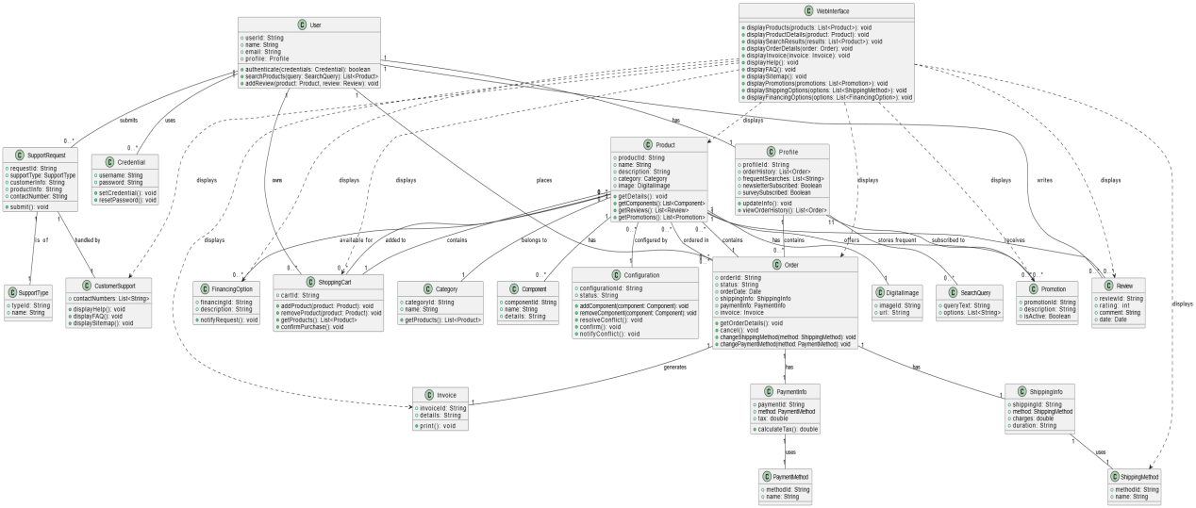

Class Diagram (VeriGen)

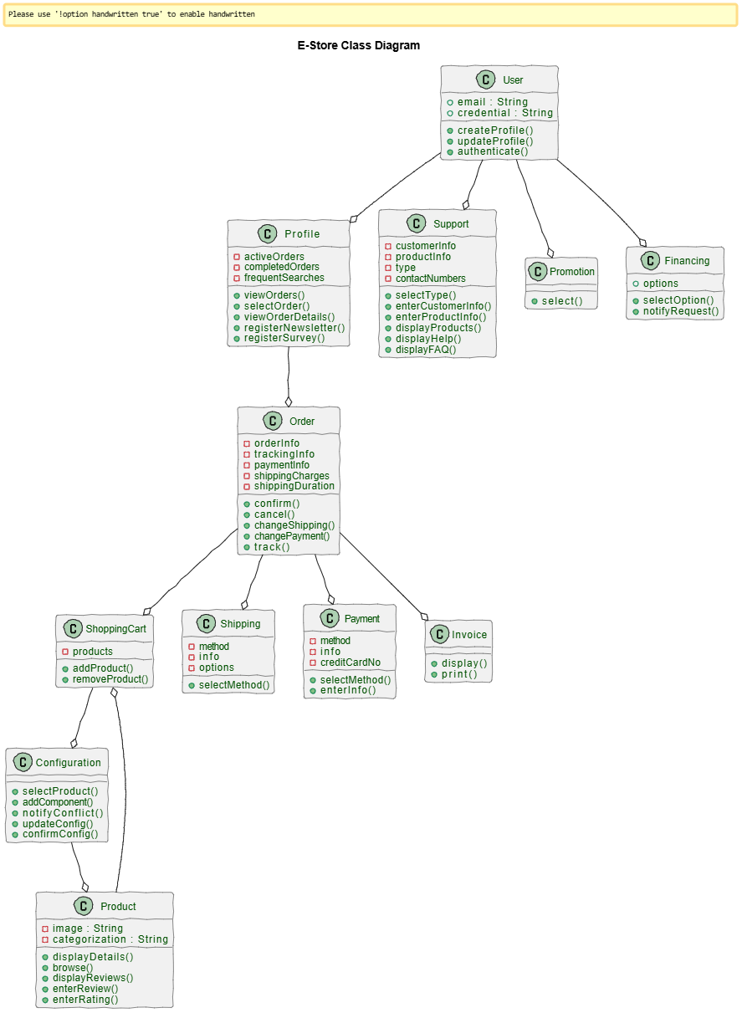

Sequence Diagram (VeriGen)
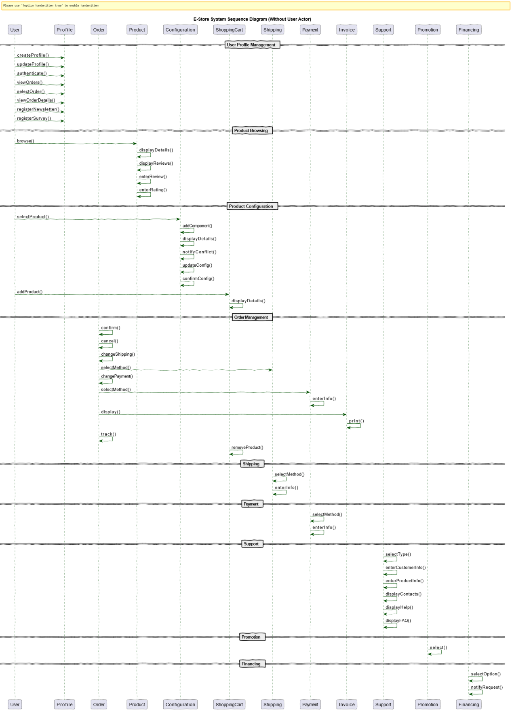

Sequence Diagram (GPT)

